

Student Name: Amina Masood
Roll.no: BSAIM-359
Section: BSAI-2E
Title Page: Haven Coffee Shop Website Design
Topic: Coffee Shop Website

Task: 1 Choose a website idea
I choose Restaurant Website (Haven Coffee Website)
Add Link: https://coffee-haven-html-css.lovable.app

Task: 2 Prompt Engineering with ChatGPT
- Prompt You Gave to ChatGPT
Give me a prompt to create a website for haven coffee shop include home, sitting area, menu, warming atmosphere, use dark brown transition
- Final Prompt Generated by ChatGPT
"Create a complete, responsive single-page website for a premium Coffee Shop using HTML and CSS. The website must include:
Modern Navbar: A sticky/fixed navigation bar with a logo (☕ Coffee Haven) and links to Home, Menu, Sitting Area, and Contact. Use a transparent-to-dark-brown transition.
Hero Section: A full-width eye-catching section with a warm background image, a bold heading 'Where Every Sip Tells a Story', and a 'View Menu' button.
Visual Coffee Menu: A clean grid layout displaying 4 items (Espresso, Cappuccino, Caramel Macchiato, and Iced Latte) with prices, short descriptions, and small circular image placeholders.
Sitting Area Gallery: A dedicated section titled 'Our Cozy Spaces' featuring a 3-column gallery (Window View, Library Nook, and Outdoor Patio). Each image should have a hover effect and a small caption.
Design Aesthetic: Use a professional colour palette of Deep Espresso (#3E2723), Cream (#FFFDD0), and Warm Gold (#D4AF37). Use 'Playfair Display' for headings and 'Poppins' for body text.
Footer: A simple footer with social media icons, opening hours, and address.

Task: 3 Generate Website Using Any AI Tool
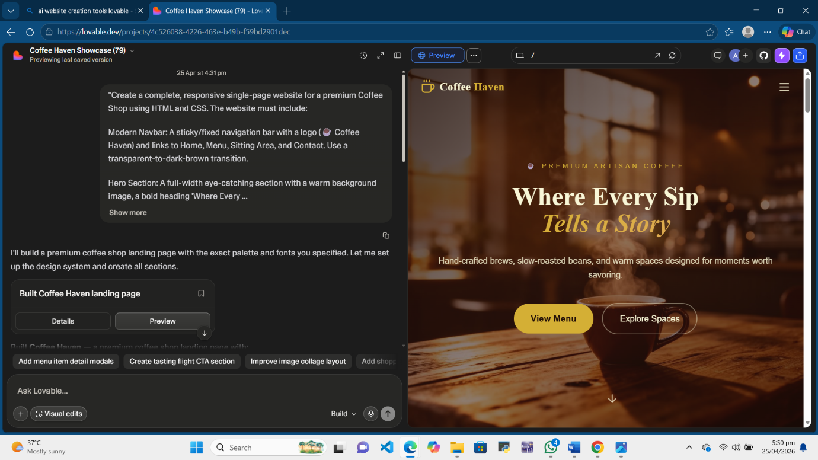

Task: 4 Required Screenshot
Screenshot 1
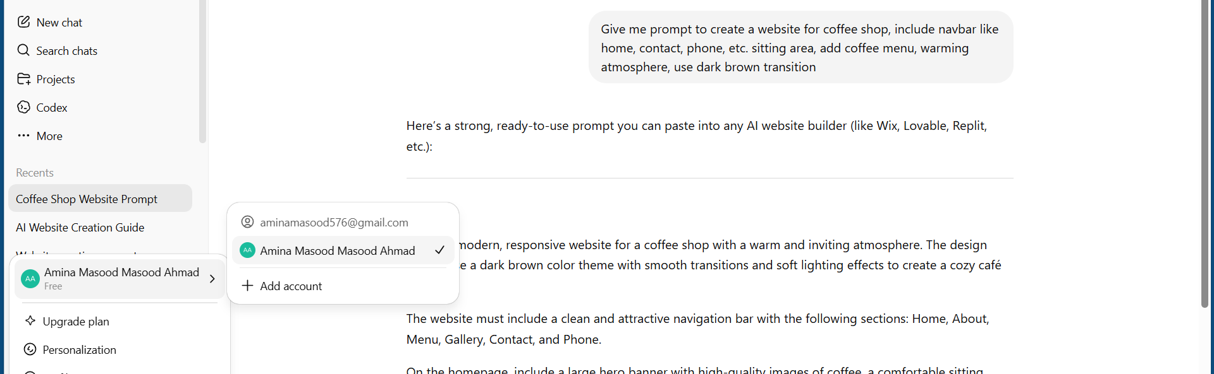
Screenshot 2
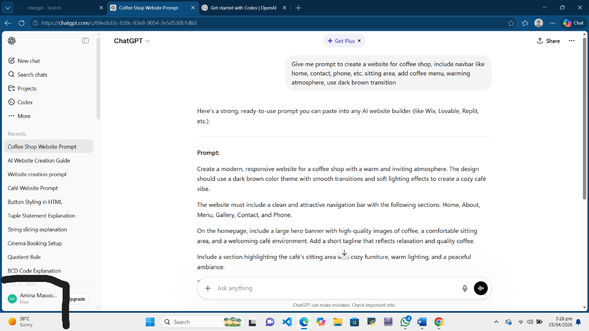
Screenshot 3


Screenshot 4
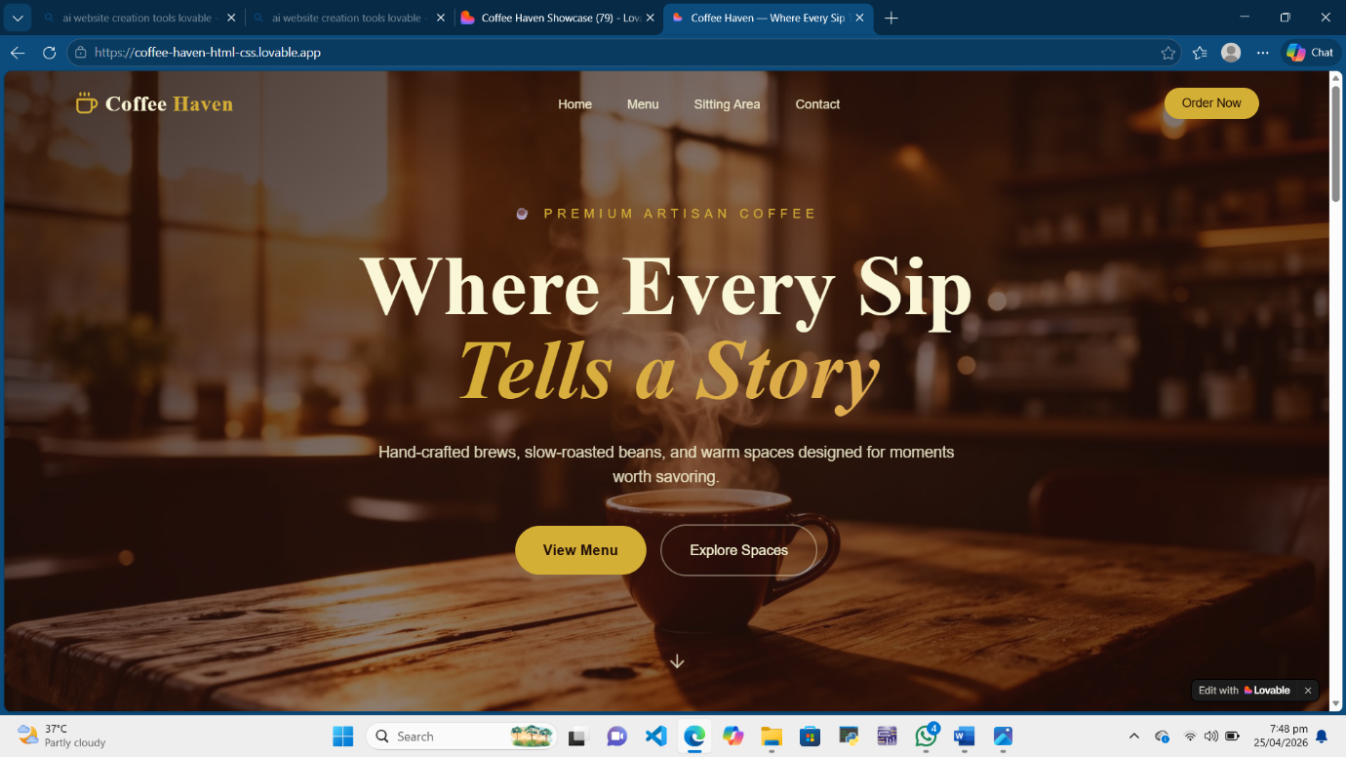

Task: 5 Generate Website Link
https://coffee-haven-html-css.lovable.app

